On 23/3/2020 I made plans to do a 2,500 mile walk around Britain to raise funds for the Alzheimer’s Society.
All my plans were delayed by Covid but eventually after three lockdowns I started my walk on my planned route on 14th July 2021. After 14 months I completed my walk on Clifton Suspension Bridge.
I had walked over 2,500 miles round the coastal towns of Britain, for most of the journey I was completely on my own. So far I have raised £68,452-00.
I am now in the middle of writing my journal of the journey. It is very time consuming as there is so much to write down. Hopefully when I have finished the journal I will be able to publish it in a book format.
I continue to raise funds so if you wish to help please donate via my JustGiving page.
Justgiving.com/fundraising/angela-hougham.
www.angelasjourney.org.uk
Facebook Angelas Journey.

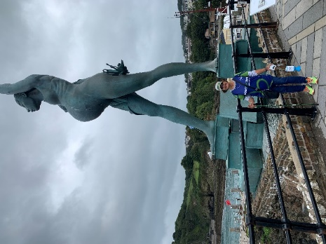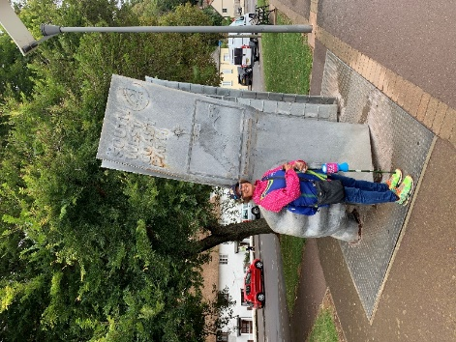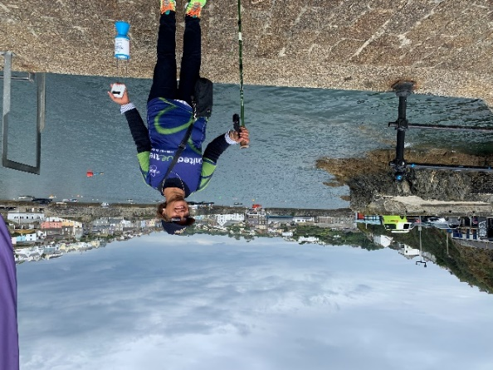
ILFRACOMBE MINEHEAD MEVAGISSEY

