Come and join us at Great Missenden Baptist Church for a time of fun including craft activities, themed story time followed by a meal.
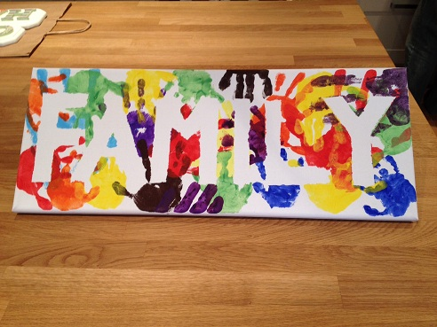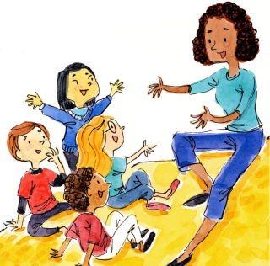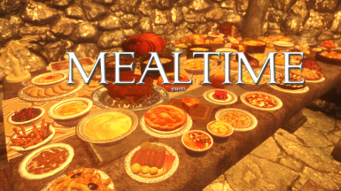
A time for families, including grandparents, parents, guardians and children of all ages to come and have fun together. There may be messy activities so please wear old clothes!
Everyone welcome. There is no charge for these sessions, donations only, but booking is required and let us know of any dietary requirements at that time please.
The next sessions will be on:
Sunday 14th May 2023 – 3.00 – 5.00PM
Sunday 11th June 2023 – 3.00 – 5.00PM
If you would like more information, or to register your place, please contact Nicki Pitt on nicolapitt672@gmail.com or phone/text 07395032432.

FAMILY FUN

