FILM NIGHT
Monday 15th January at 7.30PM
AT GREAT MISSENDEN BAPTIST CHURCH
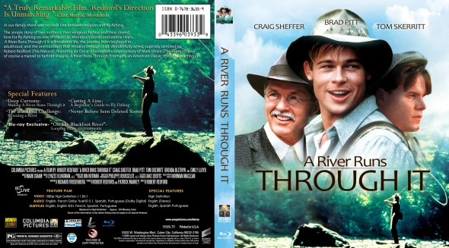
We will be showing the film “A River Runs Through It” at the church. Soft drinks, popcorn and sweets will be served.
FREE EVENT – (Donations only)
All welcome!

For more information please contact Nicki on 07395 032432 or email gmbc.secr@gmail.com

