Rev (Wg Cdr) Ashley Mitchell – Op SHADER (Air) Chaplain – HQ 903 EAW

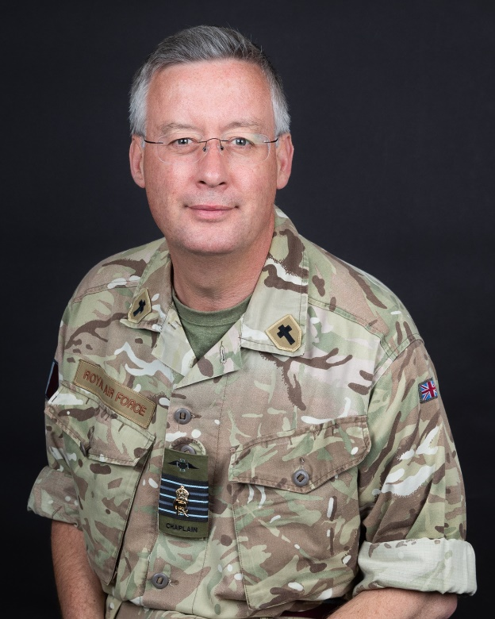

Padre Ashley Mitchell is currently serving as Op SHADER (Air) Chaplain based with HQ 903 EAW at RAF Akrotiri and travelling throughout the BME.

When not on deployment he is Senior Chaplain at RAF Halton leading the chaplaincy team to deliver pastoral care, Beliefs and Values training and Spiritual Resilience support to the whole force at Halton. During this time he has also deployed on Op KIPION, the Arabian Peninsula, from Oct 19 – Feb 20.

He also has a supervisory role providing professional support and advice to the chaplains at RAF High Wycombe, St Clement Danes and at RAF Benson within his role as regional Senior Chaplain.

Prior to arriving at RAF Halton, he was Chaplain to the European Joint Support Unit, based at SHAPE in Belgium, supporting Service Personnel and their families across Europe and Turkey.

He has also served as Senior Chaplain to RAF Marham. Previous tours have included RAF High Wycombe as Station Chaplain and SO1 Chaplaincy Personnel, Policy and Plans, RAF Odiham, serving on the directing staff at Amport House, RAF Cosford and as chaplain to ‘Joint Force Harrier’ based at RAF Wittering as well as several Army units.

He has served on deployments to the Balkans, Northern Ireland, Belize, the Middle East, Afghanistan, Libya and the Falkland Islands.

Born in Swansea, he was educated in Wales, Leeds and Cambridge, where he was prepared for ordination at Ridley Hall Theological College. Prior to serving as a military chaplain, he was Minor Canon of St Asaph Cathedral in North Wales.

He is married to Felicity, who is a Maths teacher, they have a daughter Alesha (born Nov 09), and he enjoys music, cinema, horse riding, Scottish dancing, good food and the Wendover Woods Parkrun.

Padre Mitchell was appointed Honorary Chaplain to HM King Charles III in 2023.

