Family Film
Thursday 22nd August at 11.00am
AT GREAT MISSENDEN BAPTIST CHURCH
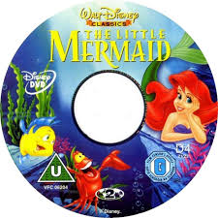
We will be showing the film “The Little Mermaid” at the church, with light buffet lunch afterwards.
FREE EVENT – (Donations only)
All welcome – any age!

For more information please contact Nicki on 07395 032432 or email gmbc.secr@gmail.com

