Family Film
Thursday 29th August at 11.00am
AT GREAT MISSENDEN BAPTIST CHURCH
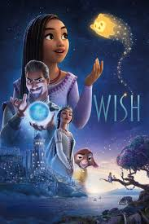
We will be showing the Disney film
“Wish” (U) at the church, with light buffet lunch afterwards.
FREE EVENT – (Donations only)
All welcome – any age!

For more information please contact Nicki on 07395 032432 or email gmbc.secr@gmail.com

