Family Film
Thursday 31st October at 11.00am
AT GREAT MISSENDEN BAPTIST CHURCH
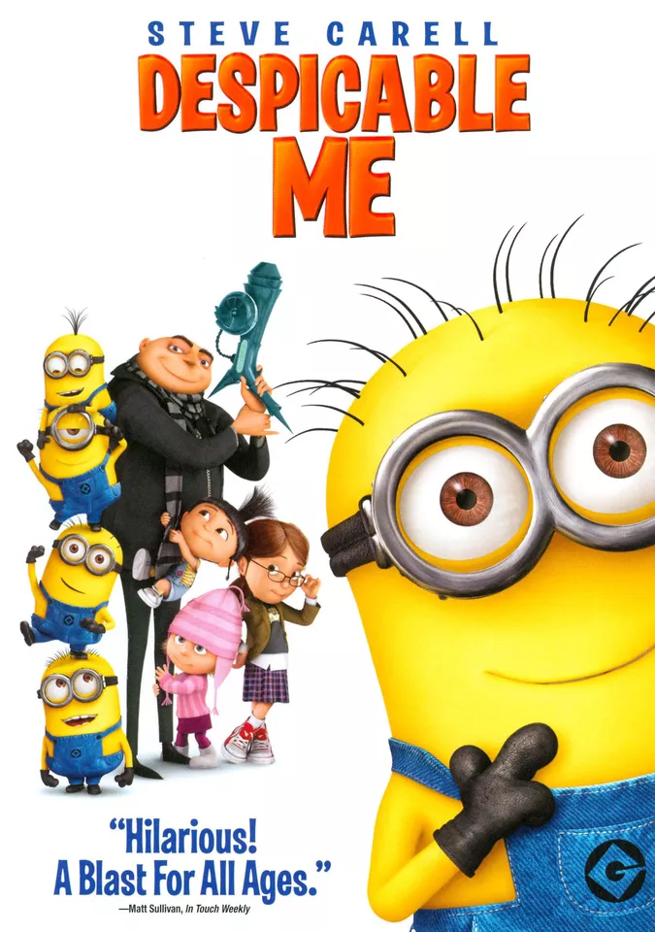
We will be showing the film “Despicable Me” at the church, with light buffet lunch afterwards.
FREE EVENT – (Donations only)
All welcome – any age!

For more information please contact Nicki on 07395 032432 or email gmbc.secr@gmail.com

