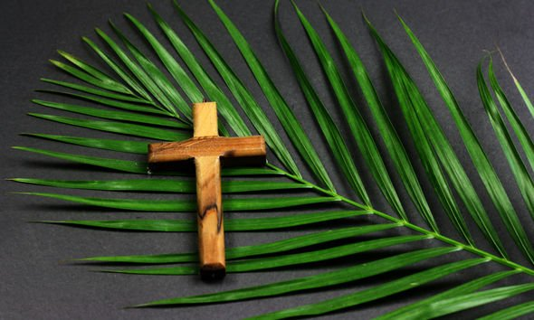
GREAT MISSENDEN BAPTIST CHURCH
WOULD LIKE TO INVITE YOU TO OUR PALM SUNDAY SERVICE
ON SUNDAY 13th April 2025
AT 3.00PM
EVERYONE WELCOME
There will be a selection of favourite Easter hymns followed by buffet refreshment.
If you require any further information please contact Nicki Pitt
On 07395 032432 or email nicolapitt672@gmail.com

