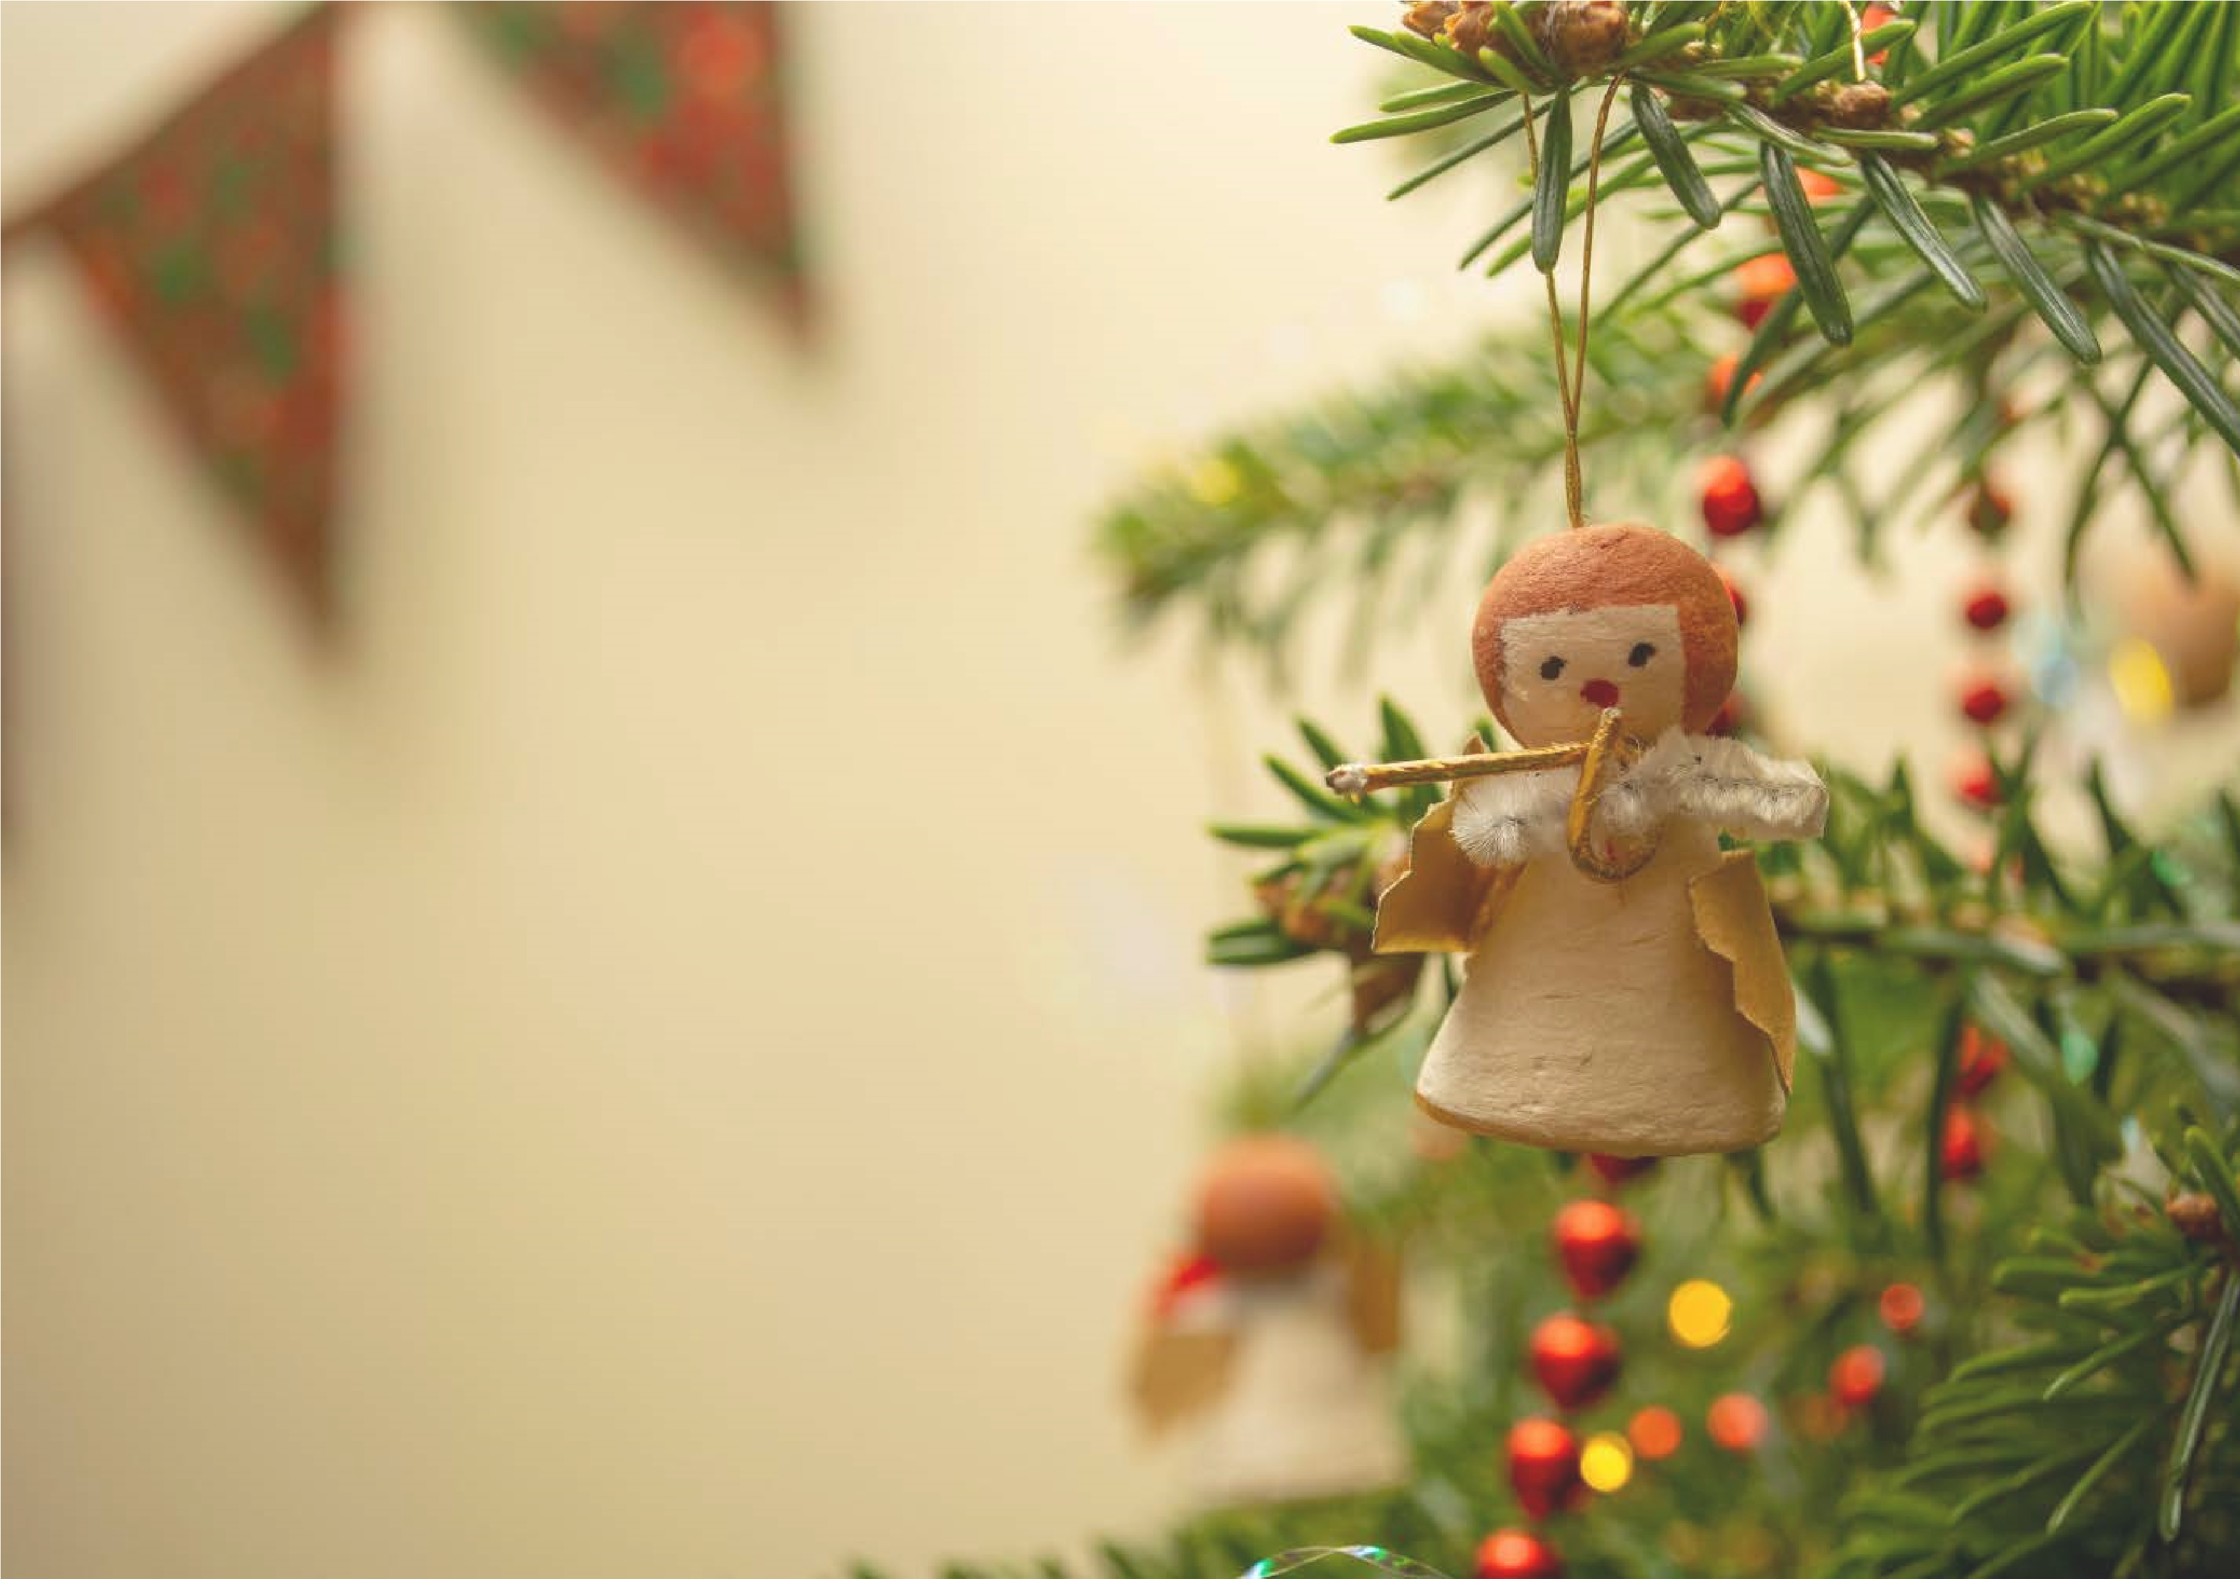

GREAT MISSENDEN
BAPTIST CHURCH
Invite you to our Nativity puppet show
Sunday 7th December 2025 at 3.00PM
We look forward to welcoming you.
If you require further information, or to book please contact
Nicki Pitt on 07395 032432
Or email nicolapitt672@gmail.com

Followed by Christmas crafts and a buffet meal
for catering purposes that would be very helpful .
There is no charge but if you could let us know you are coming

