GREAT MISSENDEN
BAPTIST CHURCH

BREAKFAST
& TALK

SAT 31st January 2026
8.30am – 10.00am
IN THE BAPTIST CHURCH HALL

You are warmly invited to join us for breakfast at the church, with a talk
by guest speaker Meriet Duncan who will speak about what we can learn from honeybees.
Breakfast is available to everyone and there is option of either cooked or continental style (including porridge).
There is a £5 charge to be paid on the day, but you will need to book
a place for catering purposes.


(If you are unable to make this contribution please still come and let us know confidentially when booking)
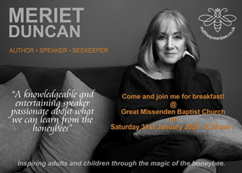

Please make a reservation by phone or email, also confirming preference for cooked or continental breakfast.

07871506797 (Andrew)

gmbc.secr@gmail.com

