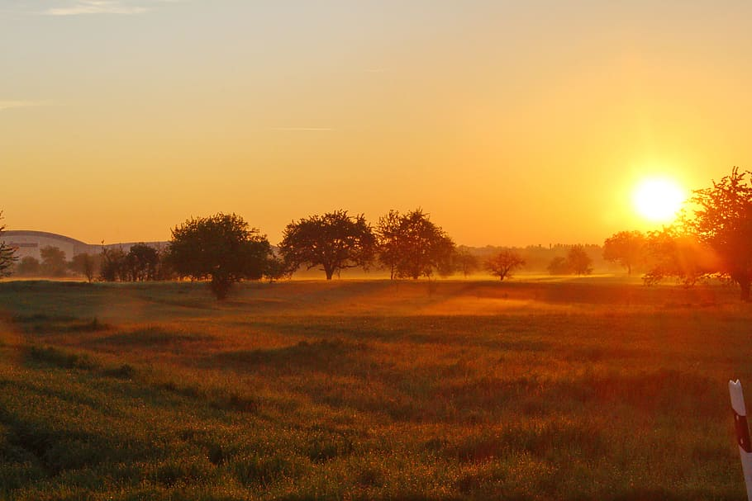
GREAT MISSENDEN BAPTIST CHURCH

COME AND WORSHIP WITH US.

AN INFORMAL WORSHIP SERVICE ON THURSDAY 5th FEBRUARY 2026 AT 7.30PM.

